**Assignment 4**

**Note : To solve below queries use “spj” database**

1. Display the PNAME and COLOR from the P table for the CITY=”London”.

**select pname,color,city from p where city='london';**

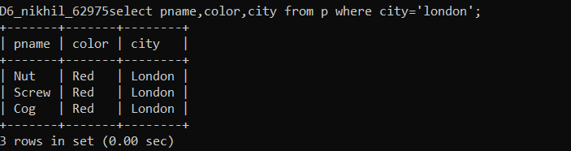

1. Display all the Suppliers from London.

**select sname,city from s where city= 'London';**

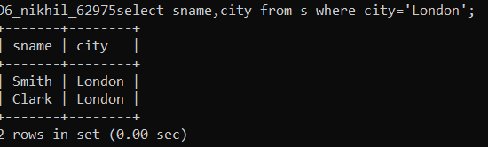

1. Display all the Suppliers from Paris or Athens .

**select sname,city from s where city in ('paris','athens');**

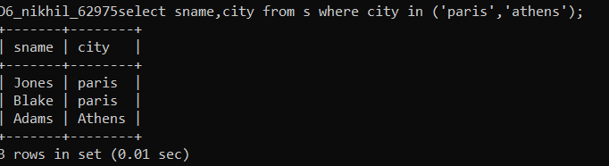

1. Display all the Projects in Athens.

**select pname,city from p where city='athens';**



1. Display all the Part names with the weight between 12 and 14 (inclusive of both).

**select pname,weight from p where weight between 12 and 14;**

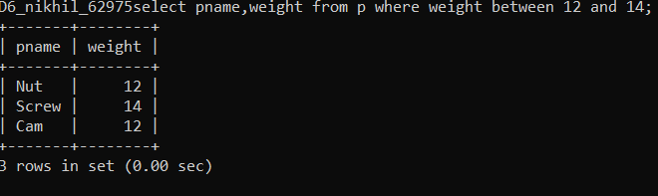

1. Display all the Suppliers with a Status greater than or equal to 20.

**select * from s where status>=20;**

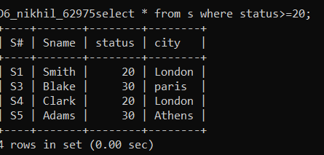

1. Display all the Suppliers except the Suppliers from London.

**select * from s where city!='London';**

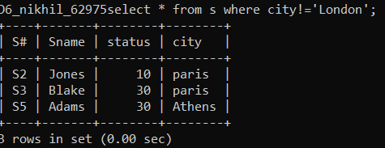

1. Display only the Cities from where the Suppliers come from.

**select city from s;**

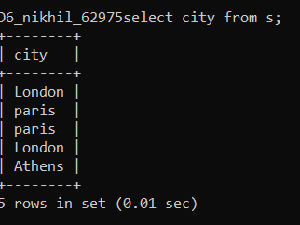

1. Display the Supplier table in the descending order of CITY.

**select * from s order by city desc;**

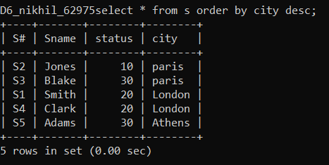

1. Display the Part Table in the ascending order of CITY and within the city in the ascending order of Part names.

**select * from p order by city,pname;**

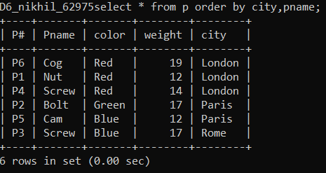

1. Display all the Suppliers with a status between 10 and 20.

**select * from s where status between 10 and 20 ;**

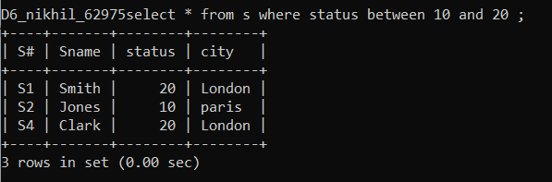

1. Display all the Parts and their Weight, which are not in the range of 10 and 15

**select * from p where not weight between 10 and 15;**

